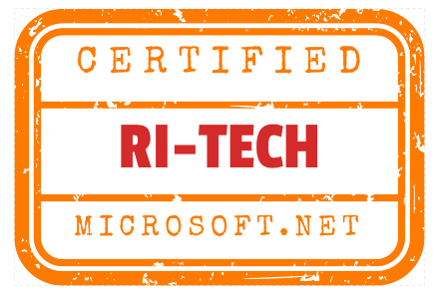
RESUME

Name:
Phone: +91- xxxxxxxxxx
Email: email@email.com

Career Objective

To secure a challenging position where I can effectively contribute my skills, and innovative ideas to gain knowledge in the work oriented environment.

Education
- Bachelor of Technology, Computer Science and Engineering
  - XXXXXX Engineering College (JNTU), Warangal.
  - Graduating Year: 2012, Aggregate: 67%
- Board of Intermediate Education (10+2)
  - xxxxxx Junior College, Kodad
  - Graduating Year: 2008, Aggregate: 91%
- Secondary School Certificate
  - xxxxxx High School, Kodad
  - Graduating Year: 2006, Aggregate: 87%

Trainings Attended

- I have completed “CORPORATE TRAINING in .NET Technology” at H-line soft pvt ltd, Hyderabad.
- Participated in the workshop based on “ANDROID APPLICATION DEVELOPEMENT” at Ramappa Engineering College”, Warangal.
- Participated in the workshop based on the “3D ANIMATION” organized by Emanagineer India at Vagdevi Engineering College, Warangal.
Technical Skills
Operating Systems | : Windows XP, Windows 7
Applications | : MS Office
Languages | : C, C++, Java, .Net
Databases | : SQL, PL/SQL, MS ACCESS

Academic Project
Project Name | : Computerized Fee Management System
Duration | : 3 months
Role | : Design and Development
Environment | : .NET
Technologies | : Web based Application, MS Access2007

The project involved development of a software application that tracks the student fee details mainly used at institutions and organizations. By using this system it provides better convenience to management. It not only provide fee details it generates daily reports, weekly reports to the management.

Achievements

- Participated in college and school level Essay competition and received applauds.
- Event organizer in school annual day functions and other technical events.

Strengths

- Able to work in a team
- System and Operational Analysis
- Good Communication Skills
- Active learning and critical thinking

Personal Details
Name :
Father’s Name :
Gender :
Date of Birth :
Contact Address :

